Tiny Dispenser

Assembly + Calibration instructons





Required Supplies

* 10 × Pieces TinyCircuits custom cut acrylic
* [1 × EMAX ES 9251 II 2.5g micro servo + package with mounting screws](https://tinycircuits.com/products/emax_2_5g_servo?_pos=5&_sid=3f280ae7d&_ss=r)
* [1 × TinyCircuits TinyZero Processor Board](https://tinycircuits.com/products/tinyzero-processor)
* [1 × TinyCircuits Servo TinyShield](https://tinycircuits.com/products/servo-tinyshield?_pos=1&_sid=3f280ae7d&_ss=r)
* 1 x TinyCircuits Wireling Adapter TinyShield
* 1 × TinyCircuits TOF Distance Sensor Wireling
* 1 × TinyCircuits Momentary Button Wireling
* [1 × 3.7v Li ion battery (close to 25mm × 10mm × 4mm)](https://tinycircuits.com/products/lithium-ion-polymer-battery-3-7v-70mah?_pos=7&_sid=7f4d0fbbe&_ss=r)
* 1 × 100mm 5-pin Wireling Cable
* 1 × 50mm 5-pin Wireling Cable
* 4 × Philips Cross-Slot M1.4 × 0.3mm (Hd. 2.0mm, L 4.3mm) Machine Screws
* 1 × M1.6 × 8 Machine Screw
* 1 × M1.6 × 5 Machine Screw
* 1 × 6-32 1.0”, 0.250” diameter round Nylon spacer
* 2 × 6-32 0.375” Nylon screws
* Small Philips Screwdriver
* Flathead Screwdriver
* [Micro USB cable](https://tinycircuits.com/products/micro-usb-cable-3-feet?_pos=1&_sid=0265853c4&_ss=r)

Helpful Tips

* Make sure to tear off the protective covering before starting assembly.
* If an acrylic piece fits too snuggly into another piece, use a file in the slot to make more room.
* All acrylic pieces have numbers on them which will be referenced in this instruction booklet.
* When inserting parts together, do not push too hard or the acrylic pieces can break.
* When done assembling, if the servo linkage (shown on page 23 in blue) to move the door to dispense food doesn’t move smoothly, then loosen the two screws in the linkage.

Visit our website at <https://tinycircuits.com> or email us at [info@tinycircuits.com](mailto:info@tinycircuits.com) for questions or help

STEP 1: Insert 1 mini servo into acrylic piece #1 so that it is flush with the face of the acrylic (note the servo’s orientation)



STEP 2: Use 2 servo mounting screws from the mini servo package to mount the servo on piece #1 (the screws shown are different than those in the package)



STEP 3: Attach 1 1.0” nylon spacer to piece #1 using 1 nylon screw (nylon screw threads not shown)



STEP 4: Insert teeth on acrylic piece #2 into slots of piece #1 ([optional] Mount the TinyZero + shields using the 4 holes on piece #2, see end of this booklet for stacking instructions)



STEP 5: Attach piece #3 to #2 using teeth and slots as shown



STEP 6: Tilt pieces #1 and #3 back and insert piece #4 in between them in the slots (note the thread’s orientation in #4)



STEP 7: Tilt pieces #1 and #3 back so that they are straight again and push #4 down



STEP 8: Slide piece #5 into the slots on pieces #1 and #3 under piece #4 and above the 1.0” nylon spacer



STEP 9: Insert the tabs on the back-wall piece #6 into the slots on the wall pieces #1 and #3 (you may need to tilt the walls). NOTE: Piece #5 is highlighted in orange.



STEP 10: Insert 1 nylon screw into the 1.0” nylon spacer through piece #3 (screws threads not shown)

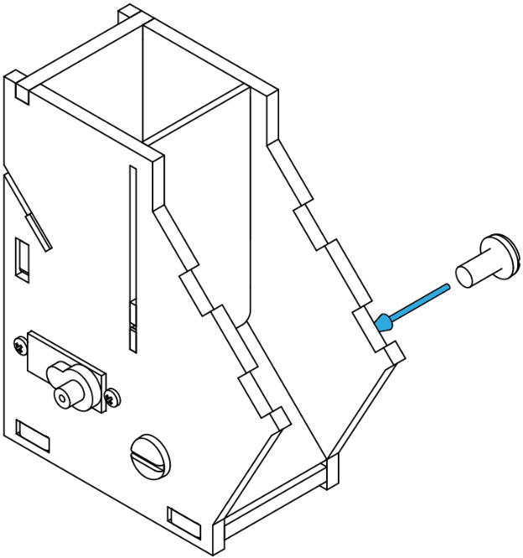



STEP 11: Push the top-front acrylic panel #7 into the slots on pieces #1 and #3



STEP 12: Use 1 M1.6 × 8 Machine Screw to attach piece #8 to the hatch piece #4

*NOTE: one side of #8 has a bigger diameter than the other. Tighten the screw just enough for free movement of piece #4.*



STEP 13: Attach piece #9 to the mini servo



STEP 14: Attach the round acrylic screw spacer using 1 M1.6×5 Machine Screw through pieces #8 and #9 (do not over-tighten the screw)



STEP 15: Use 2 M1.4×0.3mm (Hd. 2.0mm, L 4.3mm) Machine Screws to attach the Distance Sensor Wireling to piece #7



STEP 16: Plug the 100mm 5-pin cable into the Distance Sensor Wireling and through the front-most hole on the side



STEP 17: Plug the 50mm 5-pin cable into the Small Button Wireling



STEP 18: Use 2 M1.3×0.3mm (Hd. 2.0mm, L 4.3mm) Machine Screws to attach the Small Button Wireling to piece #3 and feed the 5-pin cable through the hole



STEP 19: Assembly of the case and attachment of the sensors is done! Plug the mini servo into any port of the Servo TinyShield and plug the Distance Sensor Wireling into port 0 on the Wireling Adapter TinyShield. Also, plug the Small Button Wireling into port 1 on the Adapter TinyShield. Next, put the Servo TinyShield on top of the TinyZero and the Wireling Adapter Shield on the top. Battery and electronics can fit in the back as shown below.



Calibration

After uploading the Arduino sketch file it is time to calibrate the position of the servo. Take out the screw that is holding the linkage from the servo and to the hatch together so that piece #9 (attached in step 13) is only attached to the servo.

With only piece #9 attached to the servo, try to position it like shown below.



To position the linkage highlighted in blue, do not rotate the servo, instead take the linkage off, rotate it in your hand and then put it back on. Next, insert a battery into the servo TinyShield and then press the momentary button you attached to the side of the dispenser. Pressing this will rotate the linkage to all the way open (counterclockwise) and then forced closed (clockwise). If, after pressing the button, the linkage does not settle in the position shown above repeat the process of taking the linkage off, rotating it, and then putting it back on. When done put the screw and other pieces back on.

If you hear a straining sound from the servo, the calibration might not have been completed correctly. Try to calibrate it again. If you still hear a straining/whining noise then the screws could be too tight, try to loosen them until the hatch and linkage move smoothly with little effort. Also, if the hatch comes back down and gets stuck in its slots the screws may be too tight or loose, try to adjust them.